**Հավելված N 3**

**Հայաստանի Հանրապետության**

**Արմավիրի մարզի**

**Փարաքար համայնքի ավագանու**

**2022 թվականի ապրիլի 11-ի**

**N 40-Ա որոշման**

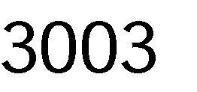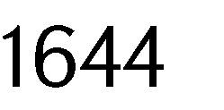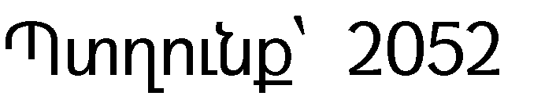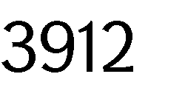



|  |  |
| --- | --- |
|  |  |
|  |  |
|  |  |
|  |  |
|  | 28 685 |

|  |  |
| --- | --- |
|  |  |
|  |  |
|  |  |
|  |  |
|  |  |

|  |  |
| --- | --- |
|  |  |
|  |  |

|  |  |
| --- | --- |
|  | *․* |
|  | •  • |
|  |  |
|  |
|  |

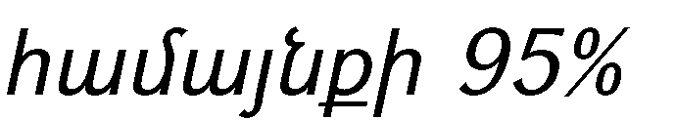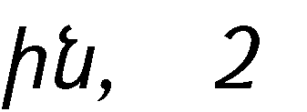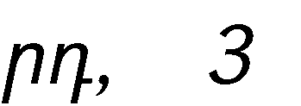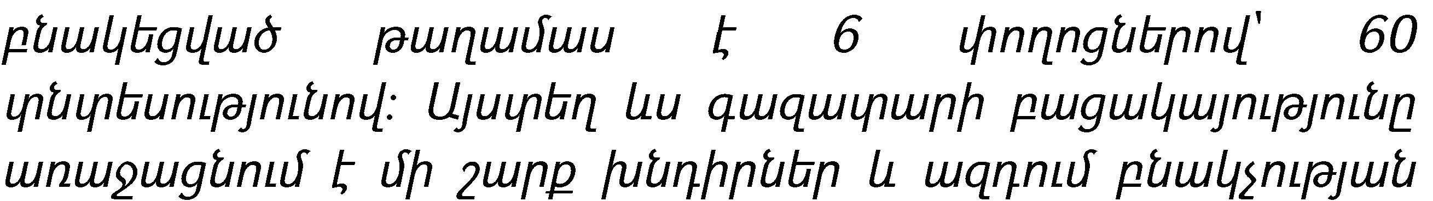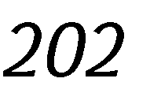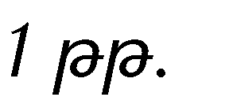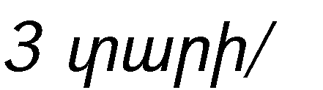

|  |  |  |  |  |
| --- | --- | --- | --- | --- |
|  | •  •  •  • | | | |
|  |  | | | |
|  |  | | | |
|  |  | | | |
|  |  | | | |
|  |  |  |  |
|  | 726 834  000 | 702 646 000 | 96,6 |
|  | 415 419  000 | 425 276 000 | 102,3 |

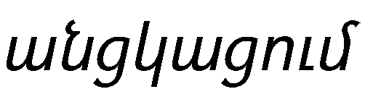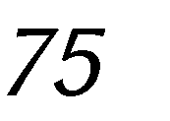

|  |  |  |  |  |  |  |
| --- | --- | --- | --- | --- | --- | --- |
|  |  | 138 257  000 | 253 291 000 | | 183,2 | |
|  | 311 415  000 | 277 370 000 | | 89,06 | |
|  | 726 834  000 | 702 646 000 | | 96,6 | |
|  | 415 419  000 | 425 276 000 | | 102,3 | |
|  | 311 415  000 | 277 370 000 | | 89,06 | |
|  | 311 415  000 | 277 370 000 | | 89,06 | |
|  |  |  | |  | |
|  |  |  | |  | |
|  |  |  | |  | |
|  |  |  | |  | |
|  |  |  | |  | |
|  |  |  | |  | |
|  |  | | | | | |
|  | | |  | |  |
|  | | | 1 446 027 800 | |  |
|  | | | 866 027 800 | |  |
|  | | | 365 000 000 | |  |
|  | | | 580 000 000 | |  |
|  | | |  | |  |
|  | | |  | |  |
|  | | |  | |  |
|  | | |  | |  |
|  | | |  | |  |
|  | | |  | |  |
|  | | |  | |  |
|  |  | | | | | |



|  |  |
| --- | --- |
|  |  |
|  |  |
|  |  |
|  |  |

